[](http://www.google.co.uk/url?sa=i&rct=j&q=&esrc=s&source=images&cd=&cad=rja&uact=8&ved=0ahUKEwiwn-vbmKLWAhVMBsAKHfYyDHUQjRwIBw&url=http://www.cpft.nhs.uk/Latest-news/Take-part-in-Health-and-Wellbeing-Week-at-CPFT&psig=AFQjCNEylJr5jdZTnh2ibJe6-SPABrqzIQ&ust=1505393137353221)

**Memory Skills Workbook  
Session 5: Effect of Mood and Wellbeing on  
 Cognitive Functioning**

**Course Overview**

Session 1 Introductions and an overview of cognitive abilities

Session 2 Overview of memory

Session 3 External memory enhancement strategies

Session 4 Internal memory enhancement strategies

**Session 5 Mood and Wellbeing on cognitive functioning**

Session 6 Strategies overview, Course reviews and goodbyes

**Introduction**

As mentioned previously, having memory difficulties can impact on lots of different aspects of our lives. This includes our mood. In this section we will explore the reciprocal impact of mood and cognitive functioning. We will also think about some strategies to help us manage how we feel, which can in turn have a positive impact on cognitive functioning. We will also be looking at how other aspects such as diet and exercise are important for our cognitive abilities.

[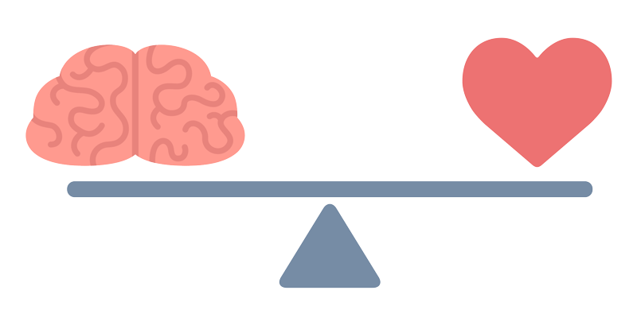](http://www.google.co.uk/url?sa=i&rct=j&q=&esrc=s&source=images&cd=&cad=rja&uact=8&ved=0ahUKEwiVsJecmqLWAhUDOsAKHYelAhcQjRwIBw&url=http://www.againsttheodds.eu/emotional-well-being&psig=AFQjCNEylJr5jdZTnh2ibJe6-SPABrqzIQ&ust=1505393137353221)

**Mindfulness**

Our minds often wander and life is sometimes filled with stresses or worries. To start off today, we will carry out a brief Mindfulness Exercise. The aim of this is just to help us be more present ‘in the moment’, and give us some time to become more aware of our thoughts, feelings and any physical sensations.

[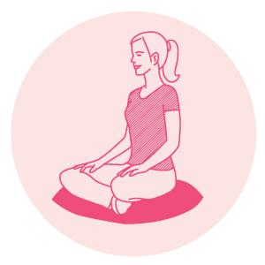](https://www.google.co.uk/url?sa=i&rct=j&q=&esrc=s&source=images&cd=&cad=rja&uact=8&ved=0ahUKEwjLicur37DWAhVLOxQKHZUEBNQQjRwIBw&url=https://www.mindful.org/meditation/mindfulness-getting-started/&psig=AFQjCNGp_64PMIuSWCwmF9rcWph0tM3psA&ust=1505893155465835)

**How our Thoughts and Mood Affect Memory**

Throughout the sessions we have mentioned how mood is important when looking at memory difficulties. The problems experienced may have an impact on how you think and feel. For example you may notice you are having a problem remembering something. This in turn causes you to have thoughts like “I’m so stupid” which can then make you feel low in mood.

[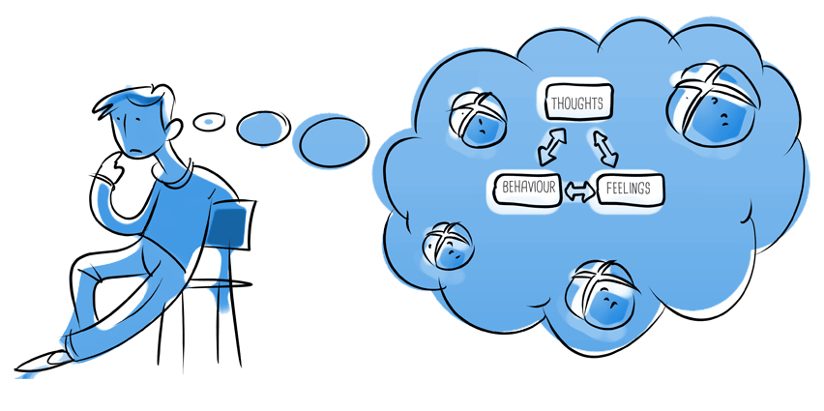](http://www.google.co.uk/url?sa=i&rct=j&q=&esrc=s&source=images&cd=&cad=rja&uact=8&ved=0ahUKEwjT4_rPnePWAhXKmLQKHQz2BvUQjRwIBw&url=http://www.intraquest.co.uk/course/cbt/&psig=AOvVaw0yIOE9Jo2-Z9xC7H20c4iH&ust=1507627836512791)

The way in which you think can influence the way you feel (emotionally and physically) which can then have an impact on your behaviour. The diagram below shows how all these are linked together in a “cycle”.

**How this can impact memory?**

So, why have we explored these ‘cycles’? What impact might they have on our cognitive functioning, including our memory? Getting caught up in a cycle of unhelpful thoughts-feelings-physical sensations-behaviour can affect these functions in several different ways:

* **Thoughts**: Being very critical of ourselves and our memory difficulties can increase stress levels. It can also mean we become more aware of times when we have difficulty with our memory and ignore any times when our memory is fine. Different kinds of unhelpful thoughts are outlined later.
  + **Distraction** – When we are focusing on worrying thoughts (known as ruminating) we divert our cognitive resources to our worries and stresses. This not only impacts on processing of new information but also means that we’re not paying attention to other things and we consequently do not process this new information.
* **Physiological changes** – As we mentioned before, the body releases hormones in reaction to stress (cortisol in reaction to low level stress and adrenaline in reaction to high level stress). This release of cortisol can result in new information not being processed properly and difficulty retrieving information we have encoded and stored.
  + **Sleep and fatigue** – When we’re feeling worried or stressed this can impact on our sleep and result in feeling tired and fatigued throughout the day. This can in turn impact on our ability to concentrate and retrieve stored information. We also consolidate new information into our memory during sleep so if we are not sleeping properly this could impact on encoding of new information into our memories.
* **Behaviour** - If we feel stressed or low in mood, sometimes we feel like doing less. We may stop engaging in activities we usually find enjoyable, or not feel like being around other people. However, doing less means we don’t get as much cognitive stimulation, which means we don't get chance to use our memory skills. Social withdrawal can also play a part in maintaining low mood and anxiety.

**Impact of cognitive functioning on mood**

Memory difficulties can affect people in different ways. For some people, memory difficulties may not be a cause for concern. However, at other times memory difficulties can have a significant impact on our thoughts about ourselves and on our mood. Whilst all these thoughts and reactions are normal, they can cause us distress. Take some time to consider your own experiences.

What impact have memory difficulties had on your mood, if any? What thoughts have you had about yourself as a result of memory difficulties? Does this in turn have an impact on how serious you perceive your memory difficulties to be? *Note down some examples in the table below.*

Think of a time when you have noticed a memory difficulty):

___________________________________________________________________________  
  
___________________________________________________________________________

|  |  |  |  |
| --- | --- | --- | --- |
| **Thoughts**  What thoughts went through your mind at the time? | **Feelings**  How did you feel? What emotions or moods did you experience? | **Physical sensations**  What changes in your body did you notice? | **Behaviour**  What did you do in this situation? |
|  |  |  |  |

**Example**

**Situation:   
Notice Memory Difficulty**

**Identifying our own cycles**

At this point, it’s really important to note that such ‘cycles’ are not uncommon. However, noticing and becoming more aware of when we are getting caught up in these thoughts and feelings can be really beneficial in itself. It means we can do something to ‘break the cycle’. This can have a positive impact on how we feel and what we do. As we’ve discussed, this can also support our cognitive functioning and memory.

[](http://www.google.co.uk/url?sa=i&rct=j&q=&esrc=s&source=images&cd=&cad=rja&uact=8&ved=0ahUKEwiRoLWXirHWAhVIOxQKHbLpCkAQjRwIBw&url=http://mishawilson.com/breaking-the-cycle-thats-really-holding-you-back/&psig=AFQjCNGffyKcWEu1ZSrqDokY--VODO8ENQ&ust=1505904661335357)

So how do we go about changing these? The first step is to think about your own cycle and how this might be impacting on your memory.

Fill in the diagram on the following page; identifying your thoughts, feelings, physical sensations and behaviours in relation to memory difficulties.

**A cycle I may become caught up in…**

**Strategies**

* Becoming more aware of thoughts and feelings
* Identifying unhelpful thoughts and beliefs
* Try a relaxation or mindfulness exercise.
* If you are imagining and believing that the worst thing possible will happen, try to think if this is actually likely to happen?
* When setting expectations for yourself, ask yourself: is this realistic?
* Sometimes we can be over critical of ourselves. If you find yourself being really negative about yourself try being kind to yourself. Think about what you would say to friend if they were saying that about themselves.
* Everyone has strengths and difficulties. It can be helpful to accept that you might not be able to change these, but you can learn to strategies manage them.
* Where possible you can also try to problem solve the negative thoughts or worries around your memory difficulties. You can do this by:
* [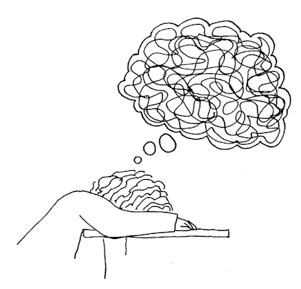](http://www.google.co.uk/url?sa=i&rct=j&q=&esrc=s&source=images&cd=&cad=rja&uact=8&ved=0ahUKEwiA94bgh7HWAhXGwBQKHbW7A5wQjRwIBw&url=http://thebullbustercafe.com/todays-lie-your-thoughts-have-no-power/&psig=AFQjCNEnDyfycJLiPXGfQ5oUOwZlPs7fbg&ust=1505903974189015)Breaking down the problem
* Looking at your strengths
* Looking at what internal and external strategies work for you
* Implementing the strategy

**Example:   
*“I’m so stupid, I forget everything. I cannot even remember to take my medication”***

- Don’t be over critical on yourself, we all have our own difficulties, none of us are perfect.  
- Do you really forget everything? What is more realistic? Is there evidence to support this?   
- What are your strengths? What strategies work for you?

**How can I distance myself from my thoughts?**

As we said, mindfulness can be used to help us defuse from our thoughts. Mindfulness is quite tricky to explain because it’s something we learn through experience over time. It is usually taught and practiced through meditation but we can be mindful in anything we do like walking, eating and even cleaning.

Mindfulness is about noticing and observing our thoughts but not getting caught up in them then switching our attention to something else like our breathing or other tasks at hand. By doing this we are able to see that thoughts are just that – thoughts. They are not facts or a part of who we are.

[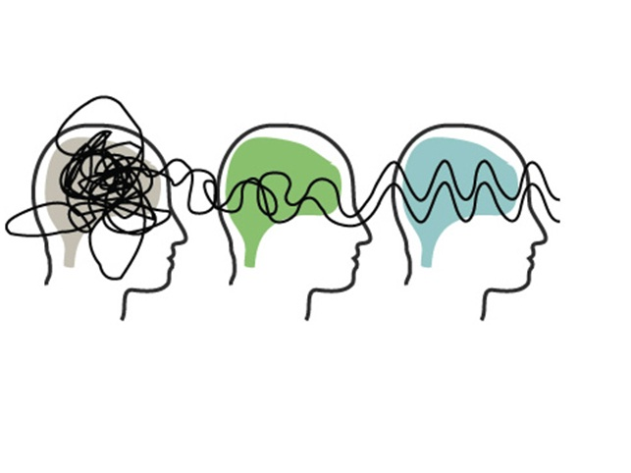](http://www.google.co.uk/url?sa=i&rct=j&q=&esrc=s&source=images&cd=&cad=rja&uact=8&ved=0ahUKEwiN4Y_fxujVAhVFVBQKHXEZC1cQjRwIBw&url=http://www.carlamaranhaopsicologia.com.br/site/?page_id%3D414&psig=AFQjCNGRkKcfFUl_yQyWKUIK01FWKZNbxg&ust=1503412659551303)

**‘Getting present’[1]**

Like we said, often in life we can find ourselves on ‘automatic pilot’; become lost in our own thoughts; or get so distracted and carried away with tasks and things to do, that we forget about what we had set out to do in the first place. For example, has it ever happened to you, that you go into a room to get something but by the time you reach the door you’ve forgotten what it was? As we’ve mentioned, all this can make it very hard for our brains to keep up, paying attention, taking information in, processing it and storing it.

As we’ve seen, mindfulness is a way of connecting to the present moment, of simply ‘being’ and noticing (purposefully, and non-judgementally) all of our body sensations and experiences. Over time, some people find that this provides them with a whole new perspective and way of living – however mindfulness techniques can also be used as a helpful strategy for choosing and learning to control our focus of attention. If we think of our minds like a computer with several programs running all at once, mindfulness can be a good way of closing down some of the many ‘tabs’ we have open (freeing up space and avoiding ‘unexpected errors’).

We can develop flexibility in our attention and contact with the present, by bringing our awareness to everyday activities, so that we can see life as it is, unfolding moment by moment (it sounds simple, but does require practice).

There are lots of activities that we usually do without thinking which we can do more ‘mindfully’ by paying full attention to it. This includes:

* Brushing your teeth
* Walking from one room to another at home or work
* Drinking tea, coffee or juice
* Taking out the rubbish
* Loading the washing machine or doing the dishes

[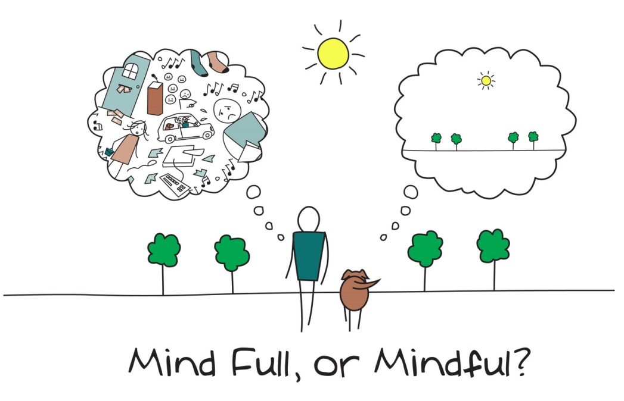](http://www.google.co.uk/url?sa=i&rct=j&q=&esrc=s&source=images&cd=&cad=rja&uact=8&ved=0ahUKEwiixJirvujVAhXGshQKHXb2BwcQjRwIBw&url=http://www.clare.cam.ac.uk/Mindfulness-at-Clare/&psig=AFQjCNFqVMNlKuTWRNvKW6TEjohXQBDjWQ&ust=1503410387427955)

Noticing your unhelpful thoughts can take some practice. Over the next week, keep an eye out and notice any occasions when you experience an unhelpful thought about memory.

Remember, we all experience these kinds of thoughts at times; try not to be hard on yourself if you do notice any. Instead, think about trying one of the strategies that we have discussed. See what impact this has on how you feel.

To help you keep a track, to use the table on the following page.

|  |  |  |
| --- | --- | --- |
| **Unhelpful thought:**  Remind yourself of the ones you most identified with on the previous worksheet. |  |  |
| **What triggered this unhelpful thought?**  What was happening, what was I doing at the time? |  |  |
| **A helpful or more balanced thought I could have instead is:**  If it’s hard to think of an alternative, try to consider what you might say to a friend in this situation? |  |  |
| **How is the alternative thought more helpful?**  Is there any other impact, i.e. memory, mood? |  |  |

**Example 1**

**Example 2**

**Wellbeing and Mood**

It’s also really important to consider how we can maintain good physical and emotional health – our general well-being.

This is because our cognitive functions do not operate in isolation: they are impacted by our physical health.

For example, our heart and blood vessels carry important oxygen and nutrients to brain cells, vital for efficient cognitive functioning.

During today’s session we will think about what we can do to promote our physical and emotional well-being.

[](http://www.google.co.uk/url?sa=i&rct=j&q=&esrc=s&source=images&cd=&cad=rja&uact=8&ved=0ahUKEwiDxcTL4rDWAhVHvxQKHSWgD6IQjRwIBw&url=http://www.dulwich.org.uk/college/academic/wellbeing&psig=AFQjCNExgKM0Xm1iiinxujZRtal0LmGR9w&ust=1505894016170242)

[](http://www.google.co.uk/url?sa=i&rct=j&q=&esrc=s&source=images&cd=&cad=rja&uact=8&ved=0ahUKEwjlmrqxgaLWAhWpKsAKHVbXAYAQjRwIBw&url=http://keywordsuggest.org/82800-healthy-food-icon.html&psig=AFQjCNGloCRyzudnSKveelj-mQ1VVrnXKg&ust=1505386902157475)**Diet**

Eating a varied and well-balanced diet is good for our general well-being – a mix of plenty of carbohydrate, plenty of fresh fruit and vegetables some protein and dairy if possible (or other sources of calcium), and just a small amount of food/drinks that are high in fat or sugar. The plate below shows a healthy balanced diet, which helps to keep cholesterol and blood pressure low. It can also support our cognitive functioning.

There has been lots of research into what particular food groups or nutrients may support cognitive functions and memory. There are also certain foods that can help promote a healthy brain such as Omega 3 fatty acid (nuts, seeds, olive oils and oily fish) and antioxidants (broccoli, blueberries and spinach). There is some evidence that B vitamins, especially B12, may also support memory functioning as we get older. Overall it seems that a healthy, varied diet is important rather than any one food group alone.

[](http://www.google.co.uk/url?sa=i&rct=j&q=&esrc=s&source=images&cd=&cad=rja&uact=8&ved=0ahUKEwjNkc2ogaLWAhWmCcAKHZ2sBvYQjRwIBw&url=http://health.usnews.com/health-news/blogs/eat-run&psig=AFQjCNHhwROYpsPqdWim5ShL887SbADj_A&ust=1505386789027438)

**Exercise**

Regular exercise helps to improve our overall health and reduce the risk of developing illness or health problems that impact on cognitive functioning. Research shows that several cardiovascular risk factors (including obesity and high blood pressure) are also risk factors for cognitive decline, so exercise can aid both physical and cognitive well-being.

Exercise also improves the flow of blood and oxygen to the brain, helping us to perform better mentally. It boosts the release of endorphins, or so-called ‘feel good’ hormones; and lots of research suggests that it can have a good impact on our emotional well-being and symptoms of stress, anxiety or low mood.

Current guidelines recommend that adults take part in moderate exercise for the equivalent of 30 minutes, 5 days a week (or 75 minutes of more vigorous exercise spread across the week). Moderate exercise means doing something that raises your heartbeat, but that you can do whilst holding a conversation.

[](http://www.google.co.uk/url?sa=i&rct=j&q=&esrc=s&source=images&cd=&cad=rja&uact=8&ved=0ahUKEwjI-JmSgKLWAhVFGsAKHQkhA5kQjRwIBw&url=http://www.istockphoto.com/illustrations/jogging&psig=AFQjCNGI2vguLgq-pBerrTf0BaswVz57ag&ust=1505386522076966)Examples include going for a brisk walk or pushing the lawnmower, so it may be easier than we sometimes think to incorporate exercise into our daily routine. For example, getting off the bus a stop early or walking to the shop rather than driving all count. Like all skills, it will take some time to notice the benefits that exercise brings, but keeping going on a regular basis will maximise those benefits.

[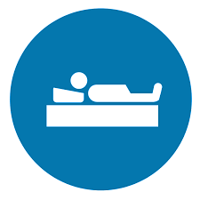](http://www.google.co.uk/url?sa=i&rct=j&q=&esrc=s&source=images&cd=&cad=rja&uact=8&ved=0ahUKEwih-PCvgqLWAhVENxQKHeLYCjcQjRwIBw&url=http://www.heritagesleep.net/&psig=AFQjCNGux0E7xTx6RzUMVOC9mMHnlDtl5Q&ust=1505387162682865)

**Sleep**

Sleep is very important and can play a huge part in the memory process. If we are feeling tired then this can make our memory worse. You may notice that when you have had little sleep it is difficulty to focus on a task or to retain information. It is recommended that you have around 6-9 hours, but this can differ from each person. There are some tips below to help you have good sleep hygiene.

* Try to go bed at the same time each night and wake up at the same time.
* Avoid caffeine, alcohol, nicotine and heavy meals before going to sleep.
* Try to do regular physical exercise, but avoid this 2 hours before bedtime.
* Have a warm bath before bed time.
* Try some relaxation exercises such as mindfulness or light yoga.
* Try to make your bedroom a relaxing environment- avoid electronics, noise and light.

[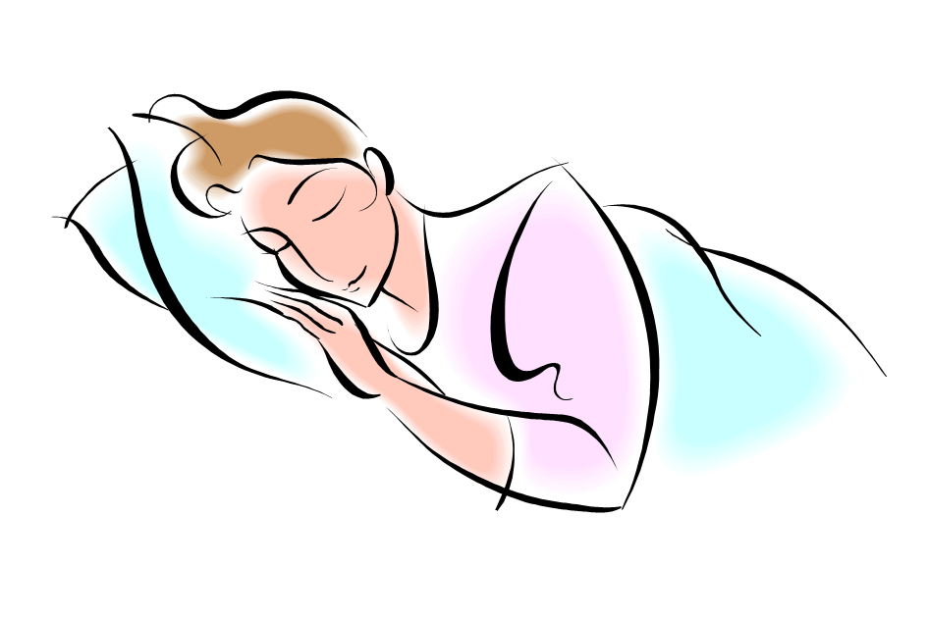](http://www.google.co.uk/url?sa=i&rct=j&q=&esrc=s&source=images&cd=&cad=rja&uact=8&ved=0ahUKEwi5__C3-6HWAhXpJsAKHVxoDuAQjRwIBw&url=http://www.picquery.com/animated-people-sleeping_hKXERpv*lQ78xbjHmQfH64Vm1d1iXPf3bcY7tO0sl1k/&psig=AFQjCNGdvm5R1lV-k8H4gUIbBoyB28jHLA&ust=1505385298125476)

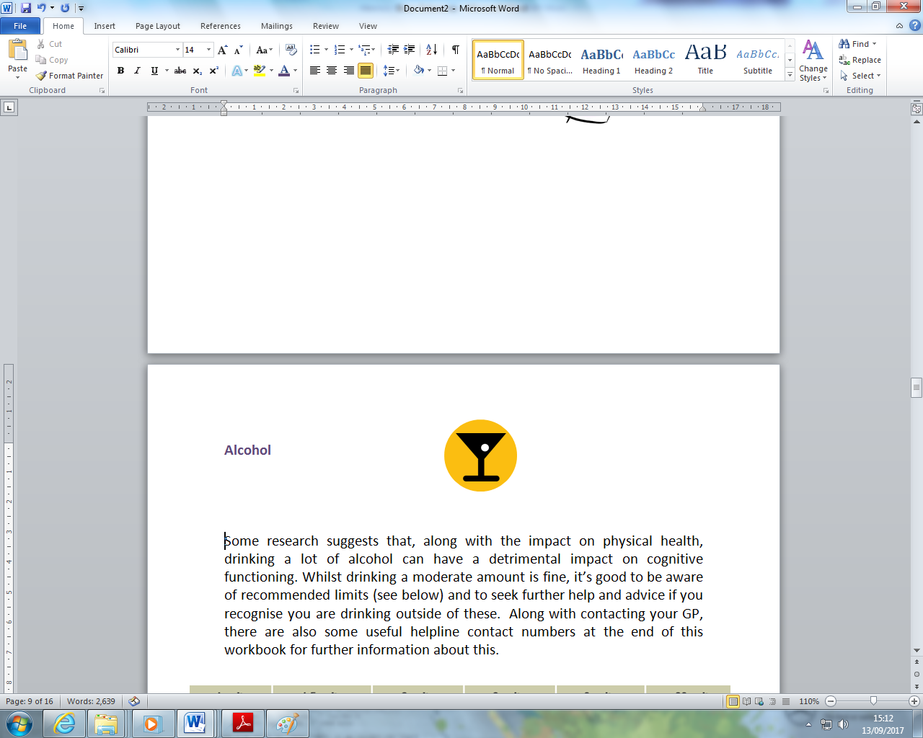**Alcohol**

Some research suggests that, along with the impact on physical health, drinking a lot of alcohol can have a detrimental impact on cognitive functioning. Whilst drinking a moderate amount is fine, it’s good to be aware of recommended limits (see below) and to seek further help and advice if you recognise you are drinking outside of these.

[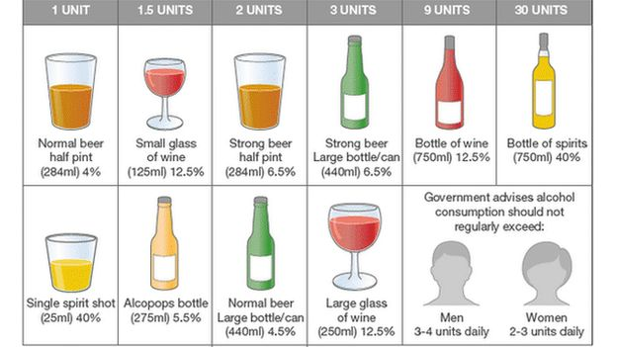](http://www.google.co.uk/url?sa=i&rct=j&q=&esrc=s&source=images&cd=&cad=rja&uact=8&ved=0ahUKEwjWm4HvsKLWAhUHchQKHaXPCQwQjRwIBw&url=http://www.bbc.co.uk/news/health-32841273&psig=AFQjCNF2VTfg_dlRfhvaJSeB1tuudG0BmA&ust=1505399550293938)

[](http://www.google.co.uk/url?sa=i&rct=j&q=&esrc=s&source=images&cd=&cad=rja&uact=8&ved=0ahUKEwilqq2trKLWAhVGsxQKHYKiBoUQjRwIBw&url=http://www.istockphoto.com/photos/no-smoking-sign&psig=AFQjCNFCZH02jBUCwCszxadGXyr2iDG1Aw&ust=1505398427238305)

**Smoking**

Smoking is another cardiovascular risk factor. This means that it increases the chance of issues such as stroke, which can affect cognitive functioning and memory. It also increases the risk of several other physical health problems. If you want any further information for support in stopping smoking, speak to one of the facilitators.

[](https://www.google.co.uk/url?sa=i&rct=j&q=&esrc=s&source=images&cd=&cad=rja&uact=8&ved=0ahUKEwjG-Zy6r6LWAhUByRQKHcFvD5gQjRwIBw&url=https://www.shareicon.net/mug-hot-drink-tea-cup-food-and-restaurant-coffee-tea-food-875036&psig=AFQjCNE-KbiH7EUt4o4OLqwiTLsrPpphGQ&ust=1505399271083162)

**Caffeine**

Large amounts of caffeine can have an impact of your sleep, which in turn can have an impact of your cognitive functioning. Some evidence suggests that excessive caffeine can have a negative effect on short term memory. Caffeine can be found in tea, coffee, chocolate, some fizzy drinks and energy drinks.

|  |
| --- |
| Use the space below to write notes if needed: |
|  |
|  |
|  |
|  |
|  |
|  |
|  |
|  |
|  |
|  |
|  |
|  |
|  |
|  |
|  |
|  |
|  |
|  |
|  |

1. This section is taken from the book ‘Mindfulness: A practical guide to finding peace in a frantic world’ by Mark Williams and Danny Penman.